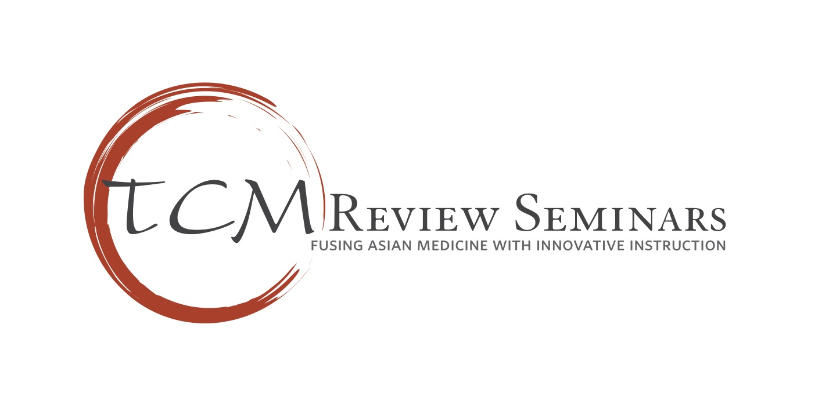
CALE Feb. 2014
Pass Rates

Overall 120 students: 90% pass rate
CAB published pass rate (all test takers from all schools combined): 49%

Breakdown By School (1st time test takers):

Total/passed
ACTCM: 18/16
AIMC: 10/9
ACCHS: 5/4
Dong-Kuk: 1/1
Emperor’s: 2/2
Five Branches: (No first time takers. Second time takers): 3/2
PCOM: 25/22
Samra: 1/1
S. Baylo: 9/6
SCHUS: 7/7
UEWM: 5/5
Yo San: 1/1

Out-Of-State: 15/13

